Identity and Access Management
  - Identity – Users, Devices, Groups and Permissions.
🔐 Understanding Identity and the Principle of Least Privilege

👤 In Information Technology, an identity represents a user, device, application, or service that requires access to organizational resources.
🛡️Every identity should be granted only the permissions necessary to perform its intended function. This security principle is known as the Principle of Least Privilege.
🏢 A practical example can be found in a corporate environment. Every employee may require a badge to enter the company building. However, access should be restricted according to job responsibilities. A Human Resources employee may access HR resources and offices, while an IT administrator may require access to IT systems, administrative portals, and server rooms. This ensures that each identity has only the permissions required to perform its assigned tasks.
⚙️ The same principle applies to applications and services. For example, a service that needs to access a database should only be granted the permissions required to complete its specific tasks. Granting excessive permissions increases the attack surface and introduces unnecessary security risks.
🚨 If a service account becomes compromised, excessive privileges may allow an attacker to access sensitive resources, access confidential information, modify critical systems, or perform unauthorized actions. For this reason, proper identity management and permission assignment are essential components of a secure environment.
🎯 The goal of Identity and Access Management is simple: provide every identity with the access required to perform its responsibilities and nothing more. By following this approach, organizations can reduce security risks, improve governance, and maintain a secure and manageable environment.

🧪 Practical Lab

👤 User Creation
👥 Group Management
🛡️ Permission Assignment
💻 Microsoft Entra Joined Device and Intune

  - 👤 User Creation
There are multiple ways to create a user account within a Microsoft 365 environment, including Microsoft Entra ID, the Microsoft 365 Admin Center, and other administrative portals.
For this lab, Microsoft Entra ID was selected because it provides a complete identity management experience and exposes all relevant user attributes required in modern enterprise environments.
Accurate and consistent user attributes are essential for administration, reporting, automation, and advanced features such as Dynamic Groups, Conditional Access policies, and identity governance.
In this scenario, realistic user accounts will be created to simulate a corporate environment. As the primary focus of this document is security, every configuration, from user accounts to security groups and permissions, will follow identity and access management best practices.
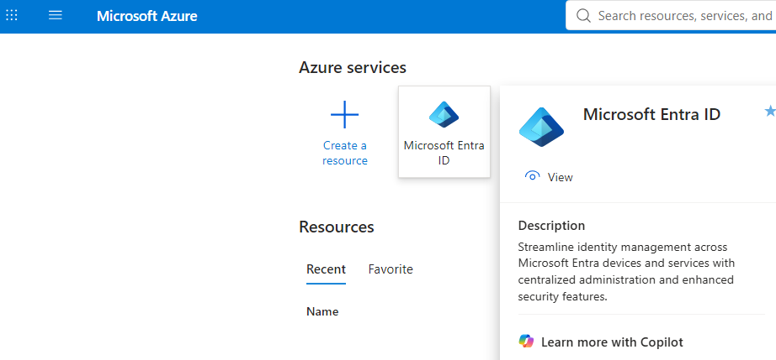
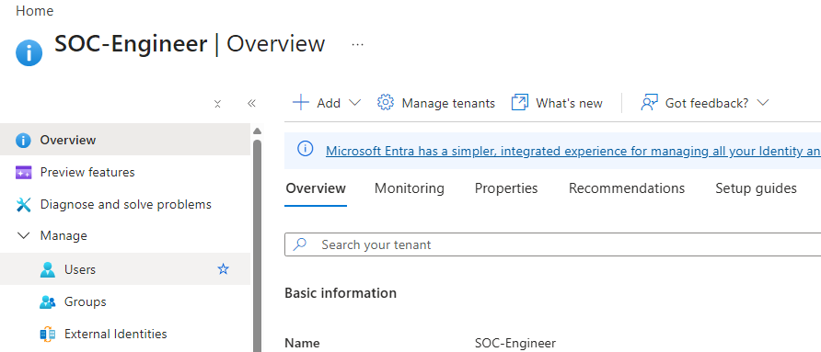
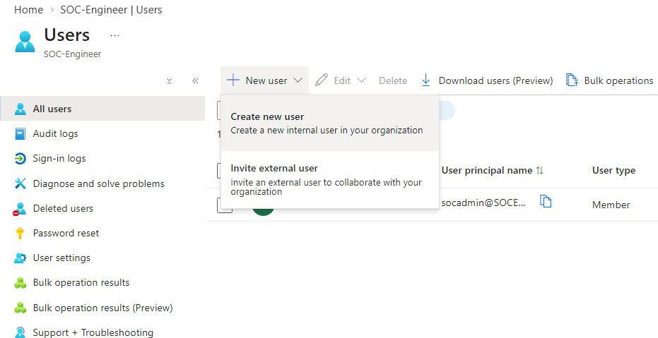

  - 📋 User Creation Process

When creating a user account in Microsoft Entra ID, the configuration process is divided into four stages:
🔹 Basics
The Basics section contains the essential information required to create the identity, such as the user's name, username (UPN), and initial password configuration.
🔹 Properties
The Properties section is used to define organizational information, including department, job title, location, and other attributes that can be leveraged for administration, automation, and dynamic group membership.
🔹 Assignments
The Assignments section allows administrators to assign groups, roles, and licenses during the user creation process, ensuring that the new identity has the appropriate access and resources from the start.
🔹 Review + Create
The Review + Create section provides a final summary of all configured settings, allowing administrators to validate the information before creating the account.

🔹 Basics
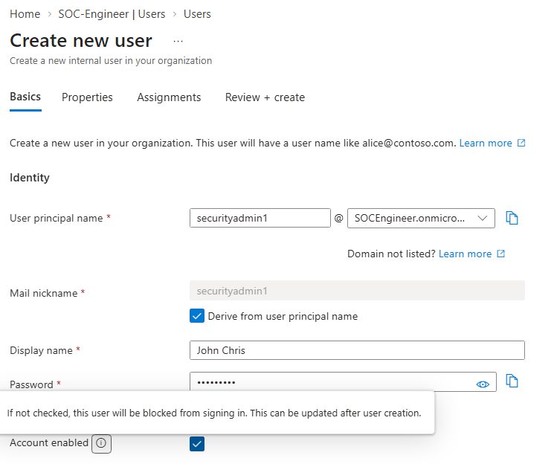

🔹 Properties
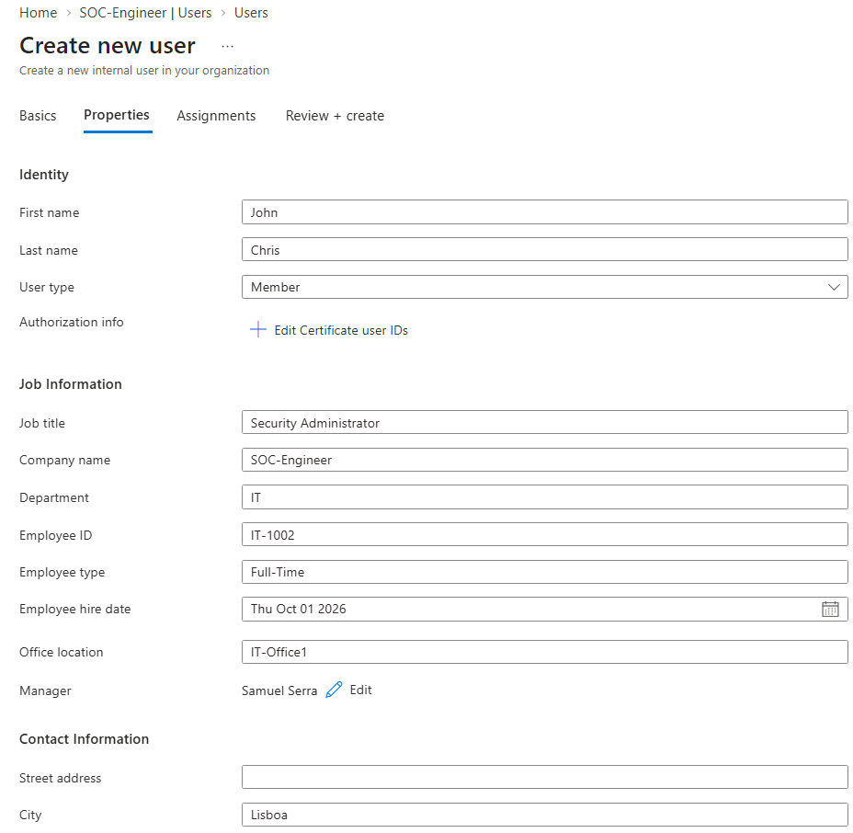
  - 📋 Attributes
User attributes should follow a standardized naming and data structure across the organization. Consistency ensures that identity information remains accurate, reliable, and accessible to all authorized stakeholders.
A lack of standardization can lead to inconsistent values being used for the same attribute, creating challenges for administration, reporting, automation, and identity governance processes.
For example, if the Department attribute contains values such as "IT", "Information Technology", and "IT Department" for users belonging to the same team, Dynamic Groups, access policies, and automated workflows may not function as expected.
For this reason, organizations should establish and enforce attribute standards to maintain a secure, scalable, and well-governed identity management environment.

🔹 Assignments
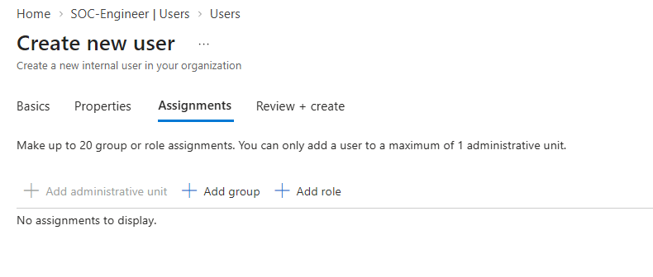
  - 👥 Assignments
At this stage, no groups are assigned to the user account. This approach was intentionally chosen to demonstrate Dynamic Group membership later in the lab, one of the most powerful Microsoft Entra ID features when implemented correctly.
As a security best practice, permissions should be assigned to groups rather than directly to individual users. Group-based access management simplifies administration, improves scalability, and reduces the risk of inconsistent permission assignments across the environment.
Instead of manually assigning permissions to every user, organizations can place users into appropriate groups and manage access centrally. This approach saves time, improves operational efficiency, and ensures that access control remains consistent throughout the organization.
Additionally, Dynamic Groups can automatically assign users to groups based on attributes such as department, job title, location, or other identity information, further reducing administrative overhead and supporting a more automated identity management model.

🔹 Review + Create
After confirming that all information is correct, the user account is created and becomes available for authentication, group membership, role assignments, and access to organizational resources.
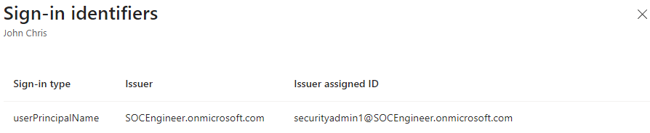
👥 Group Management and 🛡️ Permission Assignment

🔐 In this step, a Security Administrators group will be created to centralize access management and enforce security best practices throughout the environment.
👥 Rather than assigning permissions directly to individual users, permissions will be assigned at the group level. This approach simplifies administration, improves scalability, and ensures consistent access control across the organization.
⚙️ User membership will be managed dynamically based on predefined identity attributes. When implemented correctly, Dynamic Groups become one of the most powerful features of Microsoft Entra ID, reducing administrative effort while maintaining accuracy and consistency.
🎯 By leveraging standardized attributes such as Department and Job Title, users can automatically be added to the appropriate groups without manual intervention. This reduces operational overhead and minimizes the risk of configuration errors.
🛡️ Group-based access control follows the Principle of Least Privilege by ensuring that permissions are managed centrally and consistently.
💻 Once the group configuration is complete, a Windows 11 Pro virtual machine will be enrolled into the organization's cloud environment through Microsoft Entra Join.
📱 Following the device enrollment process, the device will automatically be managed through Microsoft Intune, demonstrating the integration between Identity Management, Device Management, and Security Administration.

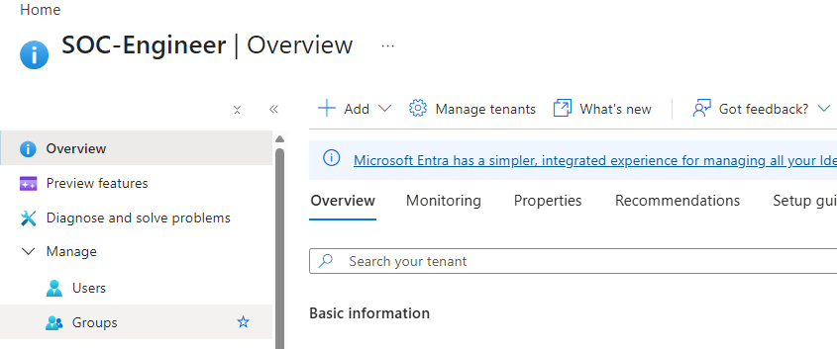

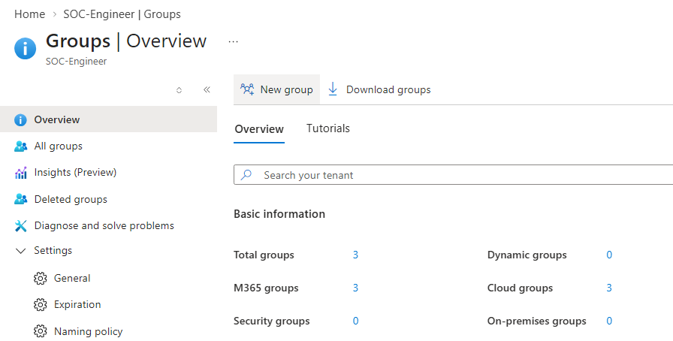
👥 Group Configuration
  - 🔐 Group Type
The Group Type defines the purpose of the group. Microsoft Entra ID provides different group types designed for specific business, collaboration, and security scenarios.
• Security Group
Security Groups are primarily used to manage permissions, access control, applications, devices, Conditional Access policies, and security-related resources throughout the environment. They are the preferred choice when implementing Identity and Access Management best practices.
• Microsoft 365 Group
Microsoft 365 Groups are designed for collaboration and productivity. They can provide shared resources such as Outlook mailboxes, calendars, Microsoft Teams workspaces, SharePoint sites, and Planner boards.
While both group types can contain users, their primary purpose is different. Security Groups focus on access management and security administration, while Microsoft 365 Groups focus on collaboration and communication.
For this lab, a Security Group was selected because the objective is to demonstrate Identity and Access Management, Dynamic Group membership, role assignments, and group-based access control.
  - 📝 Group Name
The Group Name should follow the organization's naming standards and clearly identify the group's purpose. Consistent naming conventions simplify administration, reporting, auditing, and troubleshooting activities.
  - 📖 Group Description
The Group Description provides additional context regarding the group's purpose, membership criteria, and assigned permissions. Proper documentation helps administrators understand the group's function over time.
  - 🛡️ Microsoft Entra Roles Can Be Assigned to the Group
This setting enables role-based administration through groups. Instead of assigning administrative roles directly to individual users, roles can be assigned to a group, allowing members to inherit the required privileges automatically.
This approach follows the Principle of Least Privilege and simplifies administrative management by centralizing permission assignments.
  - ⚙️ Membership Type
The Membership Type determines how users are added to the group.
• Assigned
Users are added manually by administrators.
• Dynamic User
Membership is automatically managed based on user attributes such as Department, Job Title, Location, Employee Type, or other identity properties.
• Dynamic Device
Membership is automatically managed based on device attributes and properties.
Dynamic membership significantly reduces administrative effort while ensuring that users and devices are automatically placed in the appropriate groups according to organizational policies.
  - 👤 Owners
Group Owners are responsible for managing the group, including membership, configuration, and administrative tasks related to the group.
  - 👥 Members
Members are the users or devices that belong to the group and receive the permissions, policies, applications, or resources assigned to it.
By managing permissions through groups rather than individual users, organizations can improve scalability, simplify administration, and maintain a more secure and consistent access management model.

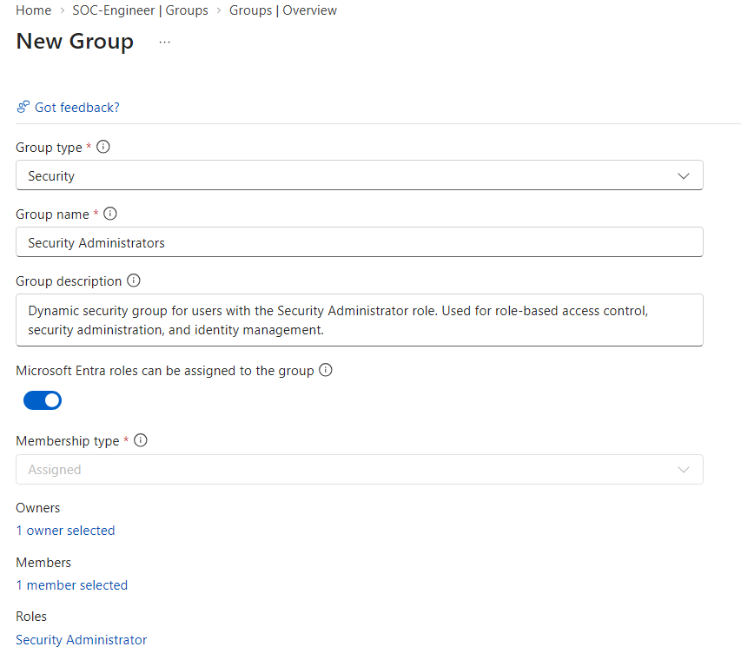
👥 Dynamic Groups and Resource Access
To demonstrate Dynamic Group membership, a second security group was created.
Groups assigned to Microsoft Entra administrative roles cannot use Dynamic Membership and must be managed manually. This restriction helps protect privileged access and reduce the risk of privilege escalation.
At this point, it is important to understand the difference between Microsoft Entra ID and Microsoft Azure.
🔐 Microsoft Entra ID manages identities, authentication, groups, and administrative roles.
☁️ Microsoft Azure manages cloud resources through Azure Role-Based Access Control (RBAC).
Because Microsoft Sentinel is an Azure resource, permissions must be assigned through Azure RBAC rather than Microsoft Entra roles.
For this reason, a dedicated SOC Analysts group was created. Azure permissions will later be assigned to this group, allowing its members to perform security operations, threat hunting, and incident investigations while following the Principle of Least Privilege.

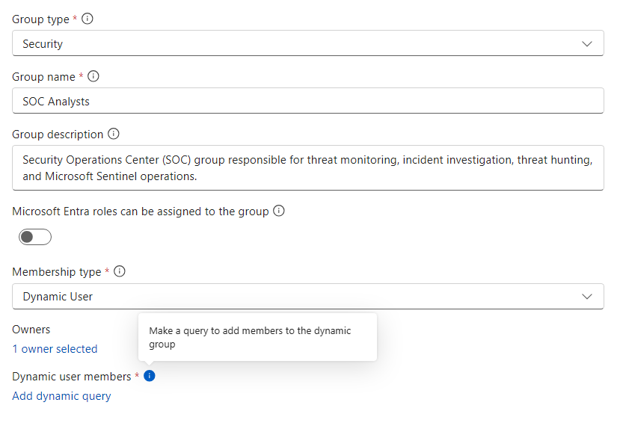
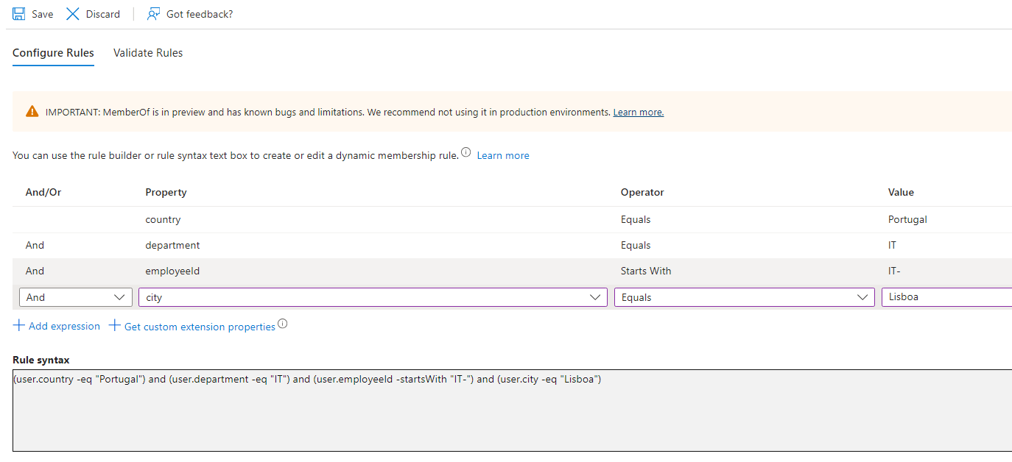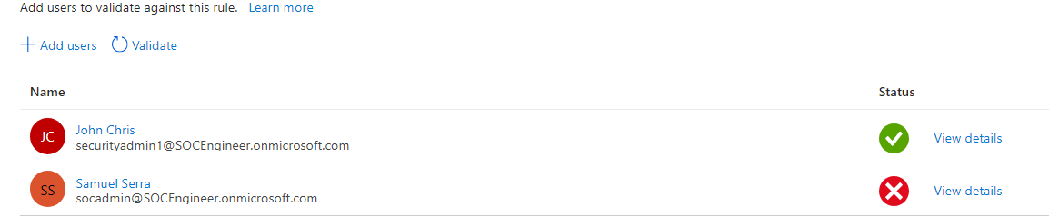

✅ Rule Validation
The Rule Validation feature allows administrators to verify which users meet the conditions defined within a Dynamic Group rule.
As shown in this lab, only John Chris matches the selected attributes and is therefore eligible for automatic group membership.
This validation process is important because it allows administrators to confirm that the configured attributes and membership rules are working as expected before the group is deployed in a production environment.
At the current stage of the lab, two users and two groups have been created. Additional users and groups will be introduced as the lab evolves to demonstrate more advanced Identity and Access Management scenarios.
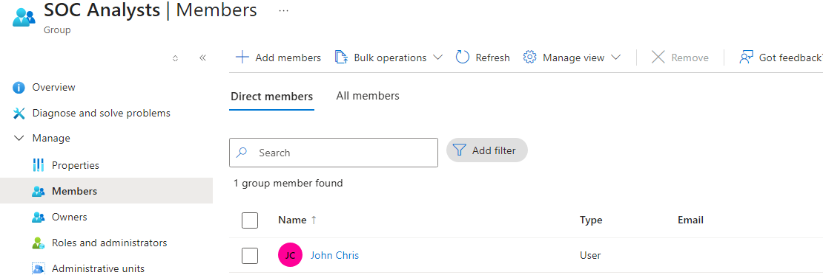
It is normal for Dynamic Group membership updates to take several minutes to process after a rule is created or modified.
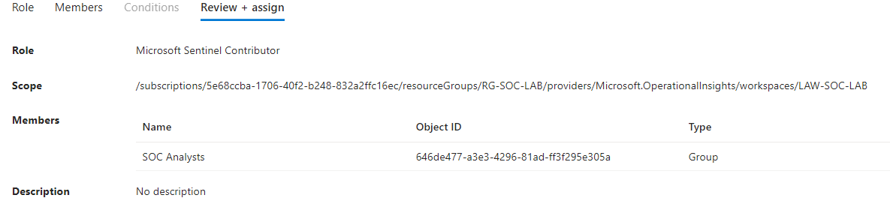
In this architecture, we implemented a Microsoft Entra ID Dynamic Group scoped exclusively to a specific Azure resource, namely Microsoft Sentinel. This dynamic group is strictly used to assign the Sentinel Contributor role. Adhering to robust role segregation and the principle of least privilege, we do not bundle multiple roles into a single group; instead, we provision dedicated groups per role to ensure granular, efficient identity governance.

💻 Microsoft Entra Joined Device and Intune

👤 A Microsoft Entra Joined Device is a cloud method to register and sign in corporate computers—physical or virtual—directly into Microsoft Entra ID.
🛡️ It connects devices to the cloud without needing an old, on-premises Active Directory server.
⚙️ This process gives Microsoft Entra ID full control to manage and secure the machine with a direct trust link.
📱 Once joined, the device automatically connects to Microsoft Intune for mobile device management, allowing IT to push security rules, apps, and updates remotely from the cloud.
🎯 The goal is to drop old local servers and manage all company devices easily and securely from a single cloud platform.

  - 💻 Microsoft Entra Joined Device Setup Requirements
👤 To perform a true Microsoft Entra Join, the device must go through the initial Windows Out-of-Box Experience (OOBE) screen, which typically requires a brand-new computer or a factory reset.
🛡️ This setup happens from the very beginning, ensuring that no personal accounts are tied to the machine and that the organization takes immediate full ownership.
⚙️ During this setup screen, the user signs in with their corporate email, which instantly blocks legacy local login methods and links the operating system to the cloud tenant.
📱 This clean deployment approach allows Microsoft Intune to take full control from second one, deploying corporate security baselines and application configurations before anyone uses the PC.
🎯 The goal is to guarantee a fresh, secure starting point, making a clean OS installation or a new device the required standard for an enterprise-managed environment.

  - ⏳ Prerequisites and Timing for Automatic MDM Enrollment
👤 The automatic enrollment settings within Microsoft Entra ID must be configured before any user attempts a Microsoft Entra Join or any other device joining workflow.
🛡️ If a device undergoes the joining process while the MDM user scope is still disabled, the machine will register its identity in the cloud directory but will completely fail to link with the management plane.
⚙️ Failing to set this up beforehand breaks the automated onboarding flow, creating a major security gap where devices sit in an unmanaged state.
🚨 To fix a device that was joined before this policy was active, administrators or users must perform a tedious, manual enrollment process on each individual machine to bring it under control.
🎯 The goal of this technical requirement is to emphasize proper execution order: cloud-side governance policies must always be established before deploying physical or virtual endpoints to production.

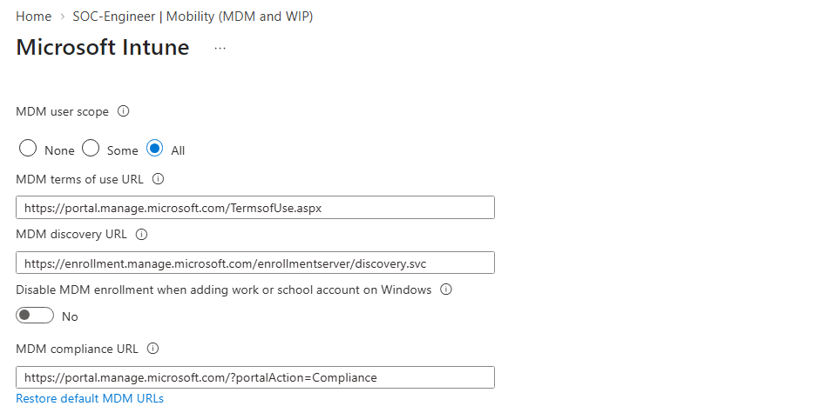
📋 Windows 11 Device Naming Deployment (Best Practices Applied)
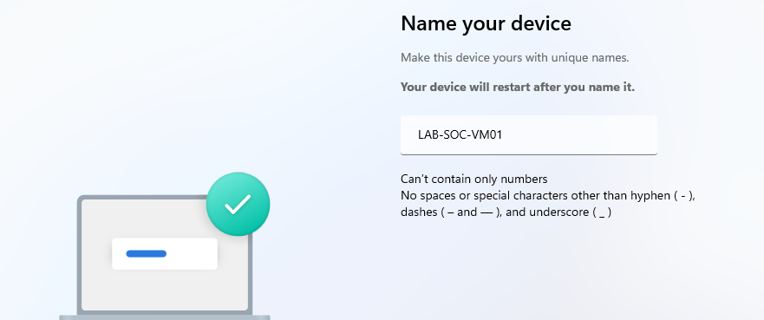

🛡️ Once the user authenticates, the Joined Device workflow and Intune Auto-Enrollment trigger immediately, seamlessly registering the Windows 11 host in both Microsoft Entra ID and Intune management.
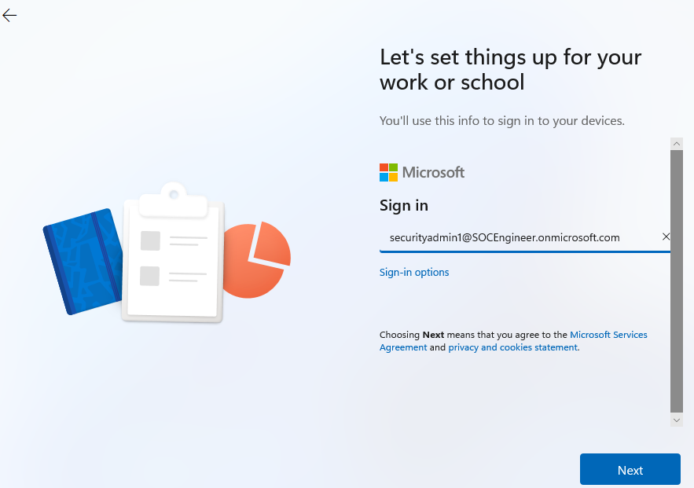
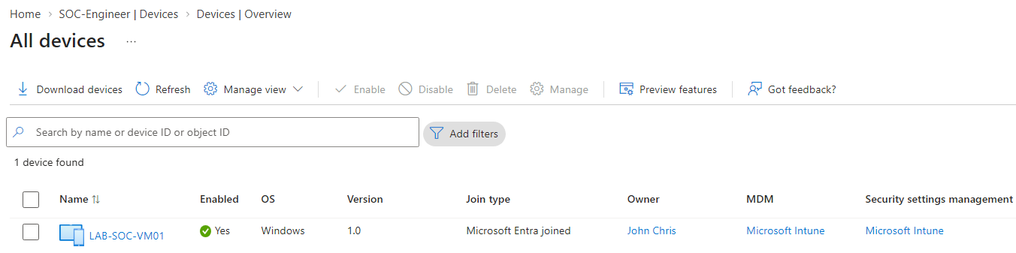
🛡️ Post-Enrollment Architecture
Once the endpoint successfully completes the Microsoft Entra Joined Device workflow, its object status becomes active within the cloud directory. The device is then automatically evaluated and captured by our designated Dynamic Device.
Production Syntax: (device.deviceOSType -eq "Windows") and (device.deviceTrustType -eq "AzureAd")
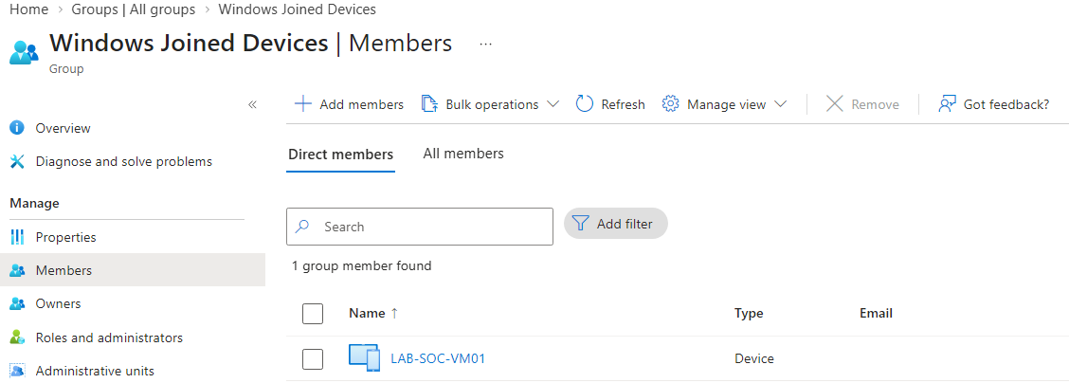
⚠️ The Golden Rule of Microsoft Cloud Services: Mandatory Licensing
A foundational factor in tenant administration is that device actions do not bypass user entitlement requirements. To utilize and interact with Microsoft corporate services such as Microsoft Entra ID, Microsoft Intune, or advanced security workloads, the authenticating user account must hold the specific active license required for each respective action.
- 🚫 Consequence of Non-Compliance: If a user attempts an enrollment or service interaction without the appropriate licensing tier (e.g., missing a Microsoft 365 E5 step), the authorization sequence will be immediately denied, triggering client-side enrollment roadblocks such as the invalid_client error.
- 📦 Architecture Standard: Administrators must guarantee that user accounts targeted for corporate provisioning are fully licensed in the Microsoft 365 admin portal prior to initiating the Out-of-Box Experience (OOBE) deployment.
